**Online Car Rental Software**

**SQL SERVER PROJECT**



**PREPARED BY:**

Nimrah Yousuf 3178-FBAS/BSSE/F16

**SUBMTTED TO:**

Ma’am Asma

**DATED:**

16th May, 2018

Contents

TABLE CREATION 3

INSERTION INTO TABLES 6

**SELECT STATEMENTS** 10

Single-row Character Functions 13

STORED PROCEDURES 20

USER DEFINED FUNCTIONS 24

SQL BUILT-IN KEYWORDS 25

VIEWS 31

# TABLE CREATION

**AdminReg Table**

CREATE TABLE AdminReg

( admin_id int PRIMARY KEY,

admin_name varchar(50) NOT NULL,

contactno varchar(50) NOT NULL,

email varchar(50) NOT NULL,

);

**Customer Table**

CREATE TABLE customer

(

custID int PRIMARY KEY,

Fullname varchar(50) NOT NULL,

custAdd varchar(50) NOT NULL,

DOB date NOT NULL,

contactno varchar(50) NOT NULL,

email varchar(50) NOT NULL,

);

**Car Table**

create table car

(

car_ID int PRIMARY KEY,

model_name text NOT NULL,

brand varchar(50) NOT NULL,

color varchar(40) NOT NULL,

NoOfseats int NOT NULL,

price money NOT NULL,

fueltype text NOT NULL

);

**Booking Table**

CREATE TABLE Booking

(

Booking_ID int PRIMARY KEY,

custID_Fk int FOREIGN KEY REFERENCES customer(custID),

Car_ID int FOREIGN KEY REFERENCES car(car_ID),

NameOfTheCar varchar(30) NOT NULL,

DateOfBooking date NOT NULL,

DeliveryAddress varchar(50) NOT NULL,

email varchar(50) NOT NULL,

NoOfCarInStock int NOT NULL,

contactno varchar(50) NOT NULL

);

**Enquiry Table**

CREATE TABLE enquiry

(

E_ID int PRIMARY KEY,

custID_Fk int FOREIGN KEY REFERENCES customer(custID),

custName varchar(30) NOT NULL,

email varchar(40) NOT NULL,

contactno varchar(50) NOT NULL,

OrderDate date NOT NULL,

ShippingDate date NOT NULL,

StatusOfOrder text NOT NULL,

);

**Feedback Table**

CREATE TABLE feedback

(

F_ID int PRIMARY KEY,

custID_Fk int FOREIGN KEY REFERENCES customer(custID),

CustName varchar(40) NOT NULL,

email_ID varchar(50) NOT NULL,

CustomerAdd varchar(50) NOT NULL,

CustCity varchar(50) NOT NULL,

PostalCode int NOT NULL,

CustContact varchar(50) NOT NULL,

ServiceReq varchar(100) NOT NULL,

Opinion text NOT NULL,

)

**Payment Table**

create table payment

(

RecieptID int PRIMARY KEY,

custID_Fk int FOREIGN KEY REFERENCES customer(custID),

CarName varchar(30) NOT NULL,

emailid varchar(50) NOT NULL,

amount money NOT NULL,

)

# INSERTION INTO TABLES

**AdminReg Insertion**

INSERT INTO AdminReg(admin_id,admin_name, contactno, email)

VALUES

(1, 'Ali Malik', '021-11111', 'Ali@gmail.com'),

(2, 'Umer khan', '051-2204786', 'Umer@outlook.com'),

(3, 'Aroosa Ghazal', '0333-5155080', 'Aroosa@gmail.com'),

(4, 'Alishma Javed', '0334-8415084', 'Alishma112@live.com'),

(5, 'Andleeb Zaib Shah', '0300-4521971', 'Andleeb22@gmail.com'),

(6, 'Maryam Musaddiq', '051-22986745', 'Maryam@gmail.com'),

(7, 'Hina Babur', '021-67528476', 'Hina@yahoo.com'),

(8, 'Natasha Saeed', '021-786743', 'Natasha@gmail.com'),

(9, 'Iqra Shahid', '051-3387364', 'Iqra@gmail.com'),

(10, 'Shohaim Yousuf', '051-3534546', 'Shohaimyousuf@gmail.com')

**Customer Insertion**

INSERT INTO Customer(custID,Fullname, custAdd, DOB, contactno, email)

VALUES

(11, 'Osama Haider', 'House 109, street#63, G-7/2-4', '1997/08/22', '021-453453', 'Osama@gmail.com'),

(12, 'Ali Zafar', '456 Glasgow street, LA', '1990/05/09', '021-5252364', ‘alizafar@gmail.com’),

(13, 'Atif Aslam', '23B Virginia city, Arlington, USA', '1990/06/24', '021-11111', 'atif90@live.com'),

(14, 'Ali Azmat', 'New Phase 34, Street 45, Islamabad', '1987/04/15', '021-15646', 'aliazmat@gmail.com'),

(15, 'James Blunt', 'Flower town, Area 001, Karachi', '1975/11/20', '051-2547457', 'james@gmail.com'),

(16, 'Calum Scott', 'Flat 13, Block 5-D, G-9/2, Islamabad', '1991/06/10', '051-3341765', 'calum@yahoo.com'),

(17, 'Chris Brown', '34 Colony North Nazimabad, karachi', '1975/12/05', '0333-34457563', 'chris@gmail.com'),

(18, 'Taylor Swift', '78D LA street, New York, USA', '1945/07/19', '02341-35235', 'taylor@hollywood.org'),

(19, 'Demi Lovato', '78 Street washington d.c, USA', '1995/08/18', '021-11-35223', 'demi90@gmail.com'),

(20, 'Marshmellow', 'New bhns colony opposite Layari, karachi', '1960/10/12', '021-11111', 'Marsh@dj.org')

**Car Insertion**

INSERT INTO car(car_ID,model_name,brand,color,NoOfseats,price,fueltype)

VALUES

(51,'2017','Mercedes', 'white', 4, 40000, 'CNG'),

(52,'G-Class','Suzuki', 'blue', 2, 30000, 'Petrol'),

(53,'XX07','Honda', 'black', 4, 45000, 'CNG'),

(54,'T-Class','Toyota', 'black', 4, 60000, 'CNG'),

(55,'2018','Volovo', 'white', 4, 19000, 'Petrol'),

(56,'Indigo Ford','Tata', 'red', 4, 50000, 'CNG'),

(57,'XX07','Bentley', 'silver', 2, 30000, 'Diesel'),

(58,'2017','Aqua', 'black', 4, 90000, 'CNG'),

(59,'2018','Mehran', 'yellow', 4, 80000, 'CNG'),

(60,'2018','Swift', 'white', 4, 50000, 'Diesel')

**Feedback Insertion**

INSERT INTO feedback(F_ID, custID_Fk, CustName, email_ID, CustomerAdd, CustCity, PostalCode, CustContact, ServiceReq, Opinion)

VALUES

(61, 11, 'Osama Haider', 'Osama@gmail.com', 'House 109, street#63, G-7/2-4', 'Islamabad', +92, '021-453453', 'Rent car', 'The service is good'),

(62, 12, 'Ali Zafar', 'alizafar@gmail.com', '456 Glasgow street, LA', 'Los Angeles', 111-44, '021-5252364', 'Event Transportation', 'I ordered cars for an event. The cars condition was good'),

(63, 13, 'Atif Aslam', 'atif90@live.com', '23B Virginia city, Arlington, USA', 'Arlington', 0003, '021-11111', 'Wedding event transportation', 'The service is nice and feasible'),

(64, 14, 'Ali Azmat', 'aliazmat@gmail.com', 'New Phase 34, Street 45, Islamabad', 'Islamabad', 44000, '021-15646', 'Rent car', 'The service is good. Everthing was fantastic'),

(65, 15, 'James Blunt', 'james@gmail.com', 'Flower town, Area 001, Karachi', 'Karachi', 650, '051-2547457', 'Business travel', 'I am highly impressed from your service. Will rent more cars'),

(66, 16, 'Calum Scott', 'calum@yahoo.com', 'Flat 13, Block 5-D, G-9/2, Islamabad', 'Islamabad', 44000, '051-3341765', 'VIP', 'The service is good. Keep it up'),

(67, 17, 'Chris Brown', 'chris@gmail.com', '34 Colony North Nazimabad, karachi', 'Karachi', 650, '0333-34457563', 'Delegation Movement', 'The service is good. Online part is good too'),

(68, 18, 'Taylor Swift', 'taylor@hollywood.org', '78D LA street, New York, USA', 'New York', +112-75, '02341-35235', 'Wedding event transportation', 'The service is good, it need to expand more'),

(69, 19, 'Demi Lovato', 'demi90@gmail.com', '78 Street washington d.c, USA', 'Washington', +0023, '021-11-35223', 'Event Transportation', 'We need more services like this'),

(70, 20, 'Marshmellow', 'Marsh@dj.org', 'New bhns colony opposite Layari, karachi', 'Karachi', 650, '021-67757', 'Business travel', 'The service is good. I am satisfied')

**Booking Insertion**

INSERT INTO Booking(Booking_ID, custID_Fk, Car_ID, NameOfTheCar, DateOfBooking, DeliveryAddress, email, NoOfCarInStock, contactno)

VALUES

(31,11, 51,'Mercedes','2018/05/22', 'House 109, street#63, G-7/2-4', 'Osama@gmail.com ', 50, '021-453453'),

(32,12,52,'Suzuki','2018/04/18', '456 Glasgow street, LA', 'alizafar@gmail.com', 100, '021-5252364'),

(33,13,51,'Mercedes','2018/05/31', '23B Virginia city, Arlington, USA', 'atif90@live.com', 20, '021-11111'),

(34,14,54,'Toyota','2018/12/01', 'New Phase 34, Street 45, Islamabad', 'aliazmat@gmail.com', 10, '021-15646'),

(35,15,55,'Volvo','2018/01/11', 'Flower town, Area 001, Karachi', 'james@gmail.com', 500, '051-2547457'),

(36,16,52,'Suzuki','2018/11/20', 'Flat 13, Block 5-D, G-9/2, Islamabad', 'calum@yahoo.com', 20, '051-3341765'),

(37,17,57,'Bentley','2017/08/10', '34 Colony North Nazimabad, karachi', 'chris@gmail.com', 30, '0333-34457563'),

(38,18,58,'Aqua','2017/06/22', '78D LA street, New York, USA', 'taylor@hollywood.org', 20, '02341-35235'),

(39,19,59,'Mehran','2017/09/07', '78 Street washington d.c, USA', 'demi90@gmail.com', 10, '021-11-35223'),

(40,20,60,'Swift','2017/02/15', 'New bhns colony opposite Layari, karachi', 'Marsh@dj.org', 50, '021-67757')

**Enquiry Insertion**

INSERT INTO enquiry(E_ID,custID_Fk,custName,email,contactno,OrderDate,ShippingDate, StatusOfOrder)

VALUES

(1111,11,'Osama Haider', 'Osama@gmail.com', '021-453453', '2018/05/22', '2018/05/23', 'Pending'),

(1112,12,'Ali Zafar', 'alizafar@gmail.com', '021-5252364', '2018/04/18', '2018/04/19', 'Sent'),

(1113,13,'Atif Aslam', 'atif90@live.com', '021-11111', '2018/05/31', '2018/06/1', 'Sent'),

(1114,14,'Ali Azmat', 'aliazmat@gmail.com', '021-15646', '2018/12/01', '2018/12/02', 'Pending'),

(1115,15,'James Blunt', 'james@gmail.com', '051-2547457', '2018/01/11', '2018/01/12', 'Sent'),

(1116,16,'Calum Scott', 'calum@yahoo.com', '051-3341765', '2018/11/20', '2018/11/21', 'Pending'),

(1117,17,'Chris Brown', 'chris@gmail.com', '0333-34457563', '2017/08/10', '2017/08/11', 'Recieved'),

(1118,18,'Taylor Swift', 'taylor@hollywood.org', '02341-35235', '2017/06/22', '2017/06/22', 'Recieved'),

(1119,19,'Demi Lovato', 'demi90@gmail.com', '021-11-35223', '2017/09/07', '2017/09/08', 'Recieved'),

(1120,20,'Marshmellow', 'Marsh@dj.org', '021-67757', '2017/02/15', '2017/02/16', 'Recieved')

**Payment Insertion**

INSERT INTO payment(RecieptID, custID_Fk, CarName, emailid, amount)

VALUES

(2001, 11, 'Mercedes', 'Osama@gmail.com', 300000),

(2002, 12, 'Suzuki', 'alizafar@gmail.com', 409800),

(2003, 13, 'Mercedes', 'atif90@live.com', 600000),

(2004, 14, 'Toyota', 'aliazmat@gmail.com', 2000000),

(2005, 15, 'Volvo', 'james@gmail.com', 450000),

(2006, 16, 'Suzuki', 'calum@yahoo.com', 100000),

(2007, 17, 'Bentley', 'chris@gmail.com', 12500),

(2008, 18, 'Aqua', 'taylor@hollywood.org', 200000),

(2009, 19, 'Mehran', 'demi90@gmail.com', 350000),

(3000, 20, 'Swift', 'Marsh@dj.org', 50000)

# **SELECT STATEMENTS**

**AdminReg**

SELECT *

FROM AdminReg;

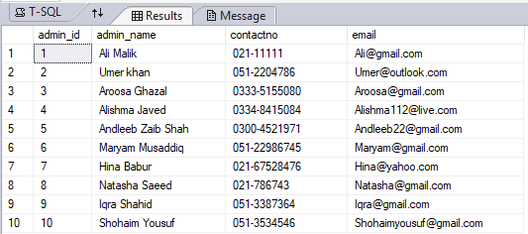

**Customer**

SELECT *

FROM customer;

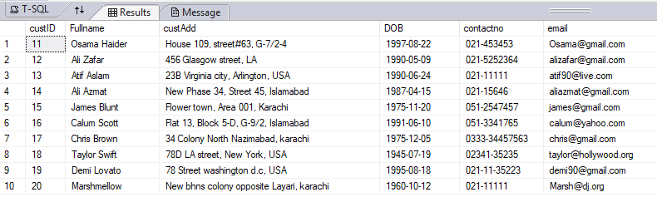

**Car**

SELECT *

FROM car;

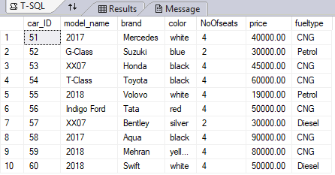

**Booking**

SELECT *

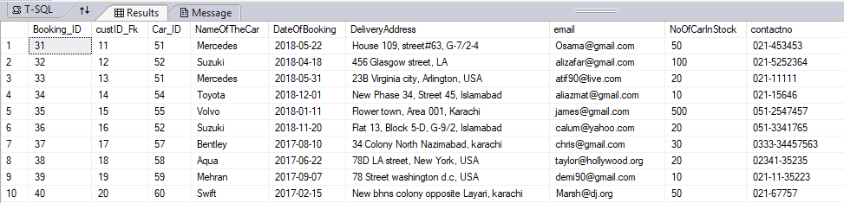FROM Booking;

**Enquiry**

SELECT *

FROM enquiry;

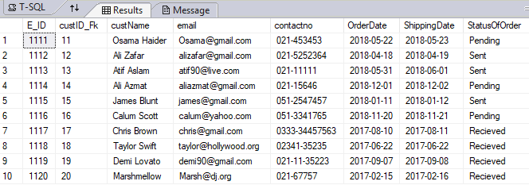

**Feedback**

SELECT *

FROM Feedback;

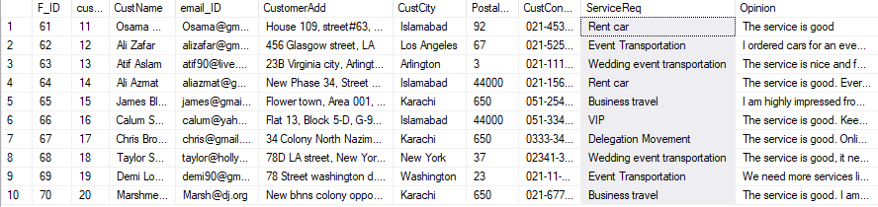

**Payment**

SELECT *

FROM payment;

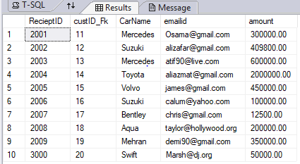

# Single-row Character Functions

1. CHAR

SELECT CHAR(F_ID) AS F_IDCharacters

FROM feedback;

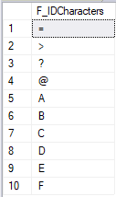

1. CONCAT

SELECT CONCAT( NameOfTheCar,' ', 'registered on ', email ) AS RegistryInfo

FROM Booking;

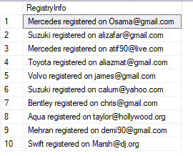

1. SUBSTRING

SELECT SUBSTRING(opinion,1,30) AS SubstringOpinion

FROM feedback;

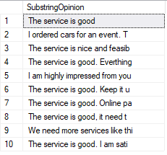

1. 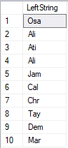LEFT

SELECT LEFT(Fullname,3) AS LeftString

FROM customer;

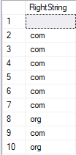

1. RIGHT

SELECT RIGHT(email,3) AS RightString

FROM Booking;

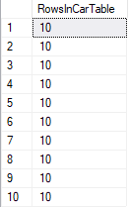

1. ROWCOUNT_BIG

SELECT ROWCOUNT_BIG() AS RowsInCarTable

FROM car;

1. REVERSE

SELECT REVERSE(email) AS ReverseEmail

FROM Booking;

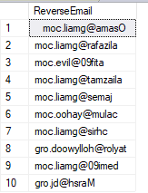

1. REPLACE

SELECT REPLACE(NameOfTheCar, 'A', '?') AS ReplaceNameOfTheCar

FROM Booking;

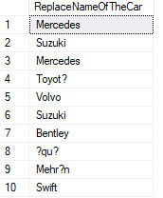

1. ASCII

SELECT ASCII(NameOfTheCar) AS ASCIIRepresentation

FROM Booking;

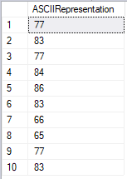

1. DATALENGTH

SELECT DATALENGTH(DeliveryAddress) AS DataLengthOfRecord

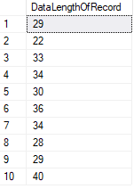FROM Booking;

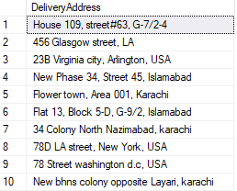

1. **DATEDIFF**

SELECT DATEDIFF(DAY, OrderDate, Shippingdate ) AS Cal_DateDiff

FROM enquiry;

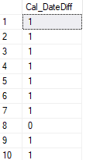

1. 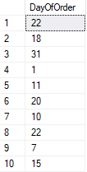DATENAME

SELECT DATENAME(DAY, OrderDate) AS DayOfOrder

FROM enquiry;

1. AVG

SELECT AVG(amount) As Avg_Amount

FROM payment;

1. MIN

SELECT MIN(price) AS MinimumPriceOfCar

FROM car;

1. MAX

SELECT MAX(amount) AS MaximumAmount

FROM payment;



1. COUNT

SELECT COUNT(brand) AS NumberOfCars

FROM car;

# STORED PROCEDURES

1. GoodOpinion

CREATE PROCEDURE GoodOpinion

AS

BEGIN

SELECT Opinion

FROM feedback

WHERE Opinion LIKE '%good%'

END

EXEC GoodOpinion

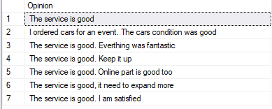

1. BookingIn2018Year

CREATE PROCEDURE BookingIn2018Year

AS

BEGIN

SELECT DATENAME(YEAR,DateOfBooking) AS Year2018 , Booking.Booking_ID, Booking.Car_ID, Booking.DateOfBooking

From Booking

GROUP BY DateOfBooking, Car_ID, Booking_ID

HAVING YEAR(DateOfBooking)=2018

END

EXEC BookingIn2018Year

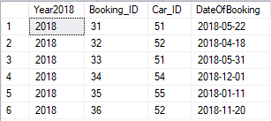

1. SimilarCars

CREATE PROCEDURE SimilarCars

AS

BEGIN

SELECT Booking.NameOfTheCar, Booking.email, car.fueltype, car.price

FROM Booking

FULL OUTER JOIN car

ON Booking.Car_ID=car.car_ID

END

EXEC SimilarCars

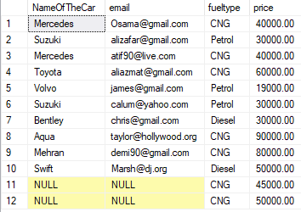

1. TotalBillOfCustomer

CREATE PROCEDURE TotalBillOfCustomer

AS

BEGIN

SELECT SUM(amount) AS TotalBill, customer.Fullname, customer.email

FROM payment

RIGHT JOIN customer

ON payment.custID_Fk=customer.custID

GROUP BY Fullname, email

END

EXEC TotalBillOfCustomer

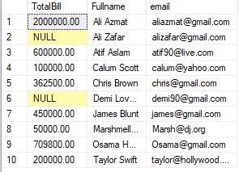

1. KarachiBookings

CREATE PROCEDURE KarachiBookings

AS

BEGIN

SELECT DeliveryAddress, contactno

FROM Booking

Where DeliveryAddress LIKE '%karachi'

END

EXEC KarachiBookings

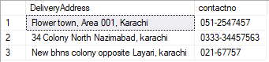

# USER DEFINED FUNCTIONS

1. TotalSales

CREATE FUNCTION TotalSales()

RETURNS MONEY

AS

BEGIN

DECLARE @Total MONEY

SELECT @Total=SUM(amount) AS TotalSales

FROM payment

RETURN @Total

END

SELECT dbo.TotalSales()



1. TotalCars

CREATE FUNCTION TotalCars()

RETURNS INT

AS

BEGIN

DECLARE @Totalcars INT

SELECT @Totalcars= COUNT(NoOfCarInStock)

FROM Booking

IF(@Totalcars<20)

BEGIN

RETURN 1

END

ELSE

BEGIN

RETURN 0

END

RETURN @Totalcars

END

SELECT dbo.TotalCars()



# SQL BUILT-IN KEYWORDS

1. DISTINCT

SELECT DISTINCT NoOfCarInStock

FROM Booking;

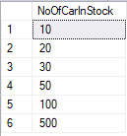

SELECT COUNT(DISTINCT CustCity) AS DistinctCities

FROM feedback;



1. WHERE

SELECT *

FROM car

WHERE color='Black';

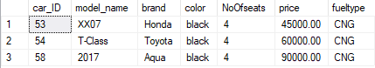

1. SELECT TOP

SELECT TOP(3) NameOfTheCar

FROM Booking

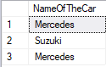

1. DELETE TOP

DELETE TOP(3)

FROM Booking

SELECT *

FROM Booking

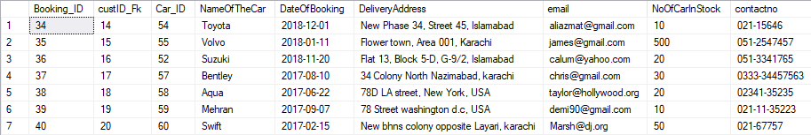

1. AND OPERATOR

SELECT *

FROM enquiry

WHERE StatusOfOrder='Pending' AND contactno LIKE '021%'

1. WILDCARDS

SELECT DeliveryAddress

FROM Booking

WHERE DeliveryAddress LIKE '%Islamabad'



SELECT model_name

FROM car

WHERE model_name LIKE '_01_'

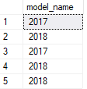

1. OR OPERATOR

SELECT CustName, ServiceReq

FROM feedback

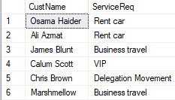

1. ORDER BY

SELECT CustName, ServiceReq

FROM feedback

WHERE CustCity='Karachi' OR CustCity='Islamabad'

ORDER BY CustName

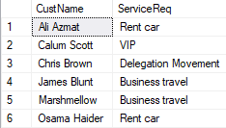

1. UNION

SELECT Booking.NameOfTheCar

FROM Booking

UNION

SELECT car.brand

FROM car

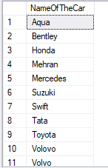

1. BETWEEN

SELECT *

FROM AdminReg

WHERE admin_id BETWEEN 2 AND 3

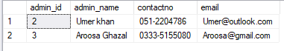

1. IN

SELECT amount, RecieptID

FROM payment

WHERE RecieptID IN(2001, 2009,3000)

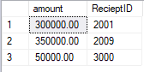

1. SELF JOIN

SELECT A.Fullname AS C1, B.Fullname AS C2

FROM customer A, customer B

WHERE A.Fullname<>B.Fullname

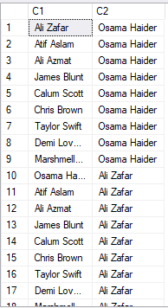

1. INTERSECTION

SELECT NameOfTheCar

FROM booking

intersect

SELECT brand

FROM car

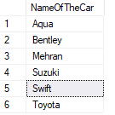

# VIEWS

1. PriceOfCars less than 50000

CREATE VIEW [PriceOfCars] AS

SELECT price

FROM car

WHERE price<50000

SELECT * FROM [PriceOfCars]



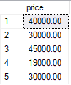

1. MinimumPrice

CREATE VIEW [MinimumAmount]

AS

SELECT MIN(amount) AS MinimumAmount

FROM payment

SELECT * FROM [MinimumAmount]



1. GSeriesModel

CREATE VIEW [GSeriesModel]

AS

SELECT car.model_name

FROM car

WHERE model_name LIKE 'G%'

SELECT * FROM [GSeriesModel]



1. PostalCodeIslamabad

CREATE VIEW [PostalCodeIslamabad]

AS

SELECT feedback.PostalCode, feedback.CustCity, feedback.CustName

FROM feedback

WHERE PostalCode=44000 AND CustCity='Islamabad'

SELECT * FROM [PostalCodeIslamabad]



1. AdminsContactNoStartingWith021

CREATE VIEW [AdminsContactNoStartingWith021]

AS

SELECT AdminReg.contactno,AdminReg.admin_name

FROM AdminReg

WHERE AdminReg.contactno LIKE '021%'

SELECT * FROM [AdminsContactNoStartingWith021]

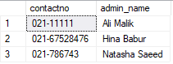

1. EXISTS

IF EXISTS( SELECT * FROM feedback WHERE CustCity='Dhoke Syedan' AND Opinion LIKE '%good%')

BEGIN

PRINT 'FOUND'

END

ELSE

BEGIN

PRINT 'Not found'

END

